Itemization

* One of but not all cases are atomic distinct
* 2 or more subclasses with at least 1 non-distinct data

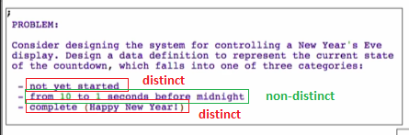

**Type comment**



**Interpretation**



**Examples**

